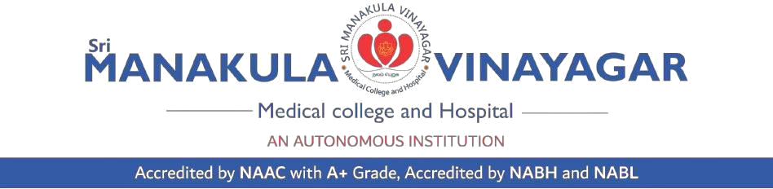

Annexure 10/SOP-6/V4

Template for Assent Form

(For Children 12-18 years of age)

Version Number: Date:

(Note: This form should be submitted along with informed consent document addressed to the parents / legally accepted representative)

Project title:

Child Participants Name:

Age of Child:

Parent / LAR’s Name:

We are doing a research study about..................................................... (Purpose in simple

language). A research study is a scientific way to learn more about people. In this study we will be.............................................................. (description of the study - Procedures, Drugs to be used, risks, discomfort, in simple language).

Everyone who takes part in this study will NOT benefit directly. A benefit means that something good happens to you. The possible benefits from this study might be........................................................................... (details of possible benefits of participation)

If you do not want to be in this research study, we will tell you what other kinds of treatments are there for you. (for research projects that offer treatment or intervention.)

When we are finished with this study we will write a report about what was learned. This report will not include your name or that you were in the study.

You can be in this study if you want to be. If you decide to stop after we begin, that’s okay too.

Your parents know about the study too.

If you decide you want to be in this study, please sign your name.

I, _________________________________, want to be in this research study.

Sign your name here

Signature of parent / legally accepted representative

Signature of Witness

Date

Date

Date

